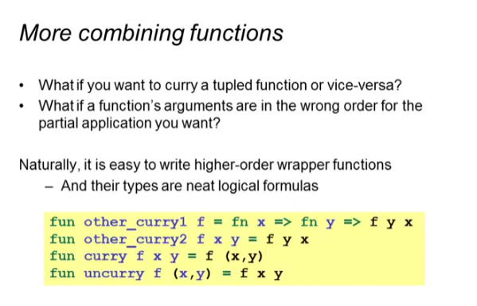

Example:

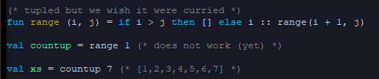

Taking a function and currying it:



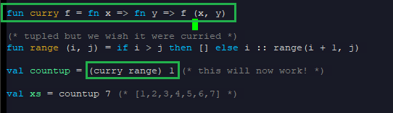

Cleaning up curry function:





Uncurry Function: (tuppling)



Types of the curry and uncurry function:



Switching the arguments in the curried function





* Swapping the first with the second argument

